New Membership Application Form

Please circle type of membership
Membership Type | Annual Fee | Concession Fee* | 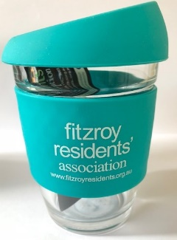
Single | $25 | $15
Family** | $35 | $20
Friends of the FRA*** | $15
FRA cup purchase (on special offer with membership renewal) | Add $10

Concession Fee entitlement: Pension recipients and full-time students;* Family membership: Please include names of all adult members; *** Do not live in Fitzroy but wish to support its objectives

Please tick these boxes to be eligible for membership:
I/we live in Fitzroy, or I/we have lived in Fitzroy.

I/we agree to be abide by the Rules & Purpose of the Association as detailed at https://fitzroyresidents.org.au/wp-content/uploads/2020/10/FRA-Rules-and-Purpose.pdf

Name/s (please print)………....……………………………………..……………..…………………….......................

Home Address:…....……………………………………….……….……………..….………………….......................

Postal Address:…....…………………………………………………...…………….………………….......................

Phone (1): ……………………………………..........Mobile(1):………………..………....…….....………………..

Phone (2): ……………………………………..........Mobile(2):………………..………....…….....………………..

Email (1): ….……………………………………………………….….…………………….......................................

Email (2): ……………………….…………………………………….…….………………….………………………..

Signature(s):……………….……………………………….…. Date: ……………………………...................

Key local issues of concern/interest……………………………………………………………………………………...

………………………………………………………………………………………………………………………………..

Please send form by post: Secretary, Fitzroy Residents’ Association (FRA), PO Box 2123, Fitzroy, 3065
or email: info@fitzroyresidents.org.au

The Secretary will be in touch about your application within 10 business days.

