Membership Renewal

Please circle type of membership
Membership Type | Annual Fee | Concession Fee* | 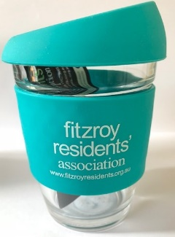
Single | $25 | $15
Family** | $35 | $20
Friends of the FRA*** | $15
FRA cup purchase (on special offer with membership renewal) | Add $10

*Concession Fee entitlement: Pension recipients and full-time students;** Family membership: Please include all names of all adult members; *** Do not live in Fitzroy but wish to support its objectives

Please tick
Amount Paid: $ ............... | Cheque (enclosed)
 | Cash
 | Donation
 | E.F.T. (please include name on payment)
 | Purchase of FRA branded cup
EFT renewal payments: via FRA Direct Credit details:
Bank: Bank Australia – Account name: Fitzroy Residents’ Association
BSB 313-140, Account No: 120 585 98 (Bank Australia account holders code: ‘FIT’)

Name/s (please print)………....……………………………………..……………..…………………….......................

Home Address:…....……………………………………….……….……………..….………………….......................

Postal Address:…....…………………………………………………...…………….………………….......................

Phone (1): ……………………………………..........Mobile(1):………………..………....…….....………………..

Phone (2): ……………………………………..........Mobile(2):………………..………....…….....………………..

Email (1): ….……………………………………………………….….…………………….......................................

Email (2): ……………………….…………………………………….…….………………….………………………..

Signature:……………….……………………………….…. Date: ……………………………...................

Key local issues of concern/interest……………………………………………………………………………………...

………………………………………………………………………………………………………………………………..

Please send form by post: Secretary, Fitzroy Residents’ Association (FRA), PO Box 2123, Fitzroy, 3065
or email: info@fitzroyresidents.org.au

