Submission to the Committee

City of Yarra Amendment C179

Residential Growth Zones

**The 3068 Neighbourhood Group**

**August 22nd 2014**

<http://www.yarracity.vic.gov.au/planning--building/Yarra-planning-scheme/Planning-Scheme-Amendments/draft-amendment-c179/>

3068 Group Submission to the Standing Committee to the Minister

# Summary

The proposed residential growth zones in Clifton Hill and North Fitzroy are unnecessary for Yarra to continue to provide a disproportionate share population of growth.

We submit that land located on Hoddle Street, Collingwood and Clifton Hill is more suited to the Residential Growth Zone than that proposed by the Amendment on Queens Parade, Clifton Hill and North Fitzroy.

“*There is plenty of land for projected residential development including commercial and industrial land; just a lack of planning. More planning and stick to it.*” - Michael Buxton.[1]

# The 3068 Neighbourhood Group

Postcode 3068 covers the areas of Clifton Hill and Fitzroy North.

The 3068 Group is a local residents group fighting to conserve the heritage and amenity of our area and to protect it from the encroachment of unsympathetic development.

We are best known for the successful campaign to save the *House of the Gentle Bunyip* from demolition.

# AIMS

* To conserve the heritage, streetscape character and amenity of the postcode area of 3068, taking in Clifton Hill and Fitzroy North.
* To protect sites of heritage significance in this area from damage.
* To assist residents to resist inappropriate and unsympathetic developments in the area.
* To improve the planning process and outcomes for residents.
* To support the development of sympathetic building projects which respect the heritage character of the 3068 area.
* To promote the value and significance of heritage within Yarra to residents, Council and the wider community.

# Introduction

Specifically this submission addresses the North Fitzroy and Clifton Hill Residential Growth Zones.

The strategic justification for the amendment in the explanatory report is lacking:

### “Why is the amendment required?

“The amendment is required to implement the Residential Growth Zone into the Yarra Planning Scheme.

“The amendment will **guide residential development into targeted areas** which will encourage the valued character and amenity of established residential areas to be protected.

### “How does the amendment implement the objectives of planning in Victoria?

“Amendment C179 is considered to implement the objectives of planning in Victoria by achieving a **balanced** **approach** towards housing provision within Yarra, **providing** **increased housing capacity in locations that are accessible and appropriate**.”

Yarra already has an established and successful policy to ‘**guide residential development into targeted areas**’ providing ‘**increased housing capacity into locations that are accessible and appropriate**’. In Yarra’s case these are former industrial sites.

We submit that land on Hoddle Street at Clifton Hill and at Victoria Park has greater accessibility, more capacity and fewer amenity constraints on housing growth and diversity than that proposed in the Amendment and shares many of the strategic attributes of the Urban Renewal areas in Plan Melbourne.

Prime land presently zoned B1Z, B3Z, B4Z and MUZ[2] near the Clifton Hill and Victoria Park railway stations on the South Morang & Hurstbridge lines is under-developed.

This land is currently used for timber and builders’ hardware, two bathroom supplies, luxury car repairs, a tyre service, self-storage, a concrete batching plant, insurance offices, truck accessories and hamburgers.[3]

Land zoned PUZ on Alexandra Parade, Smith Street and Queens Parade, the former Collingwood gasworks remains under-developed. The gas works is a 6 ha site.

# Proposed Rezoning or Residential Areas in the heritage overlay

**Objective of the Residential Zones:**A suite of statutory tools for a planning authority to implement state and local policies and strategies to better plan for residential development.[4]  
  
The Residential Growth Zone (RGZ) enables new housing growth and diversity[5].

Since Melbourne 2030 was proposed in 2000, Yarra’s policy has been to direct significant development to former industrial land. This reduces development pressure on historic residential precincts, which have been densely developed since the 19th century, while providing a diversity of development opportunities.

Directing development away from Activity Centres, which in Yarra are historic retail streets, was considered to be in conflict with the state planning provisions for Melbourne 2030. This policy is discussed in depth the interim and final panel report for Amendment C84.[6] Ultimately the conflict was resolved in Yarra’s favour.

The *Housing and Population Report* supporting this amendment (C179) provides evidence that this policy has been successful. Yarra has grown at 860 residents per annum since 1991 but since 2007 this trend has increased sharply to 1,500 new residents per annum.

“The recent boost in dwelling supply seems to relate to the increasing size and scale of development rather than growth in the overall number of active construction projects in the municipality.

“Table 5 shows the ongoing increase in the number of high yielding development projects within the municipality. These projects most often convert redundant commercial and industrial sites into apartment blocks which in turn are steadily transforming a number of Yarra’s major streets into higher density residential areas (Victoria Street for instance).

While there have been “*vastly more apartments approved for construction than approvals of any other type of dwelling (see Figure 8)*”. This is not necessarily a bad outcome given the demographics of Yarra. In fact it may be an appropriate market response.

“Yarra’s recent population growth has been driven by the attractiveness of the municipality to couples without children, lone person and group households, who now make up the vast majority of Yarra’s households” [pg6]

The DTPLI report agrees with this [pg16]

In Yarra, as with all of the central city, small scale unit development in residential areas is comparatively far less prevalent **and less critical** to new dwelling supply (providing around 10% of new dwellings per annum).

Given the acknowledgement of ‘less critical’, we **disagree** with the report’s conclusion that the proposed application of the RGZ:

will create realistic opportunity for further housing diversity in Yarra’s residential areas – DTPLI analysis shows that there are approximately 60 sites of sufficient size to achieve RGZ objectives

has the potential to provide a different lower scale apartment development different in scale and density to the types of projects currently occurring in Richmond and Collingwood.

**The growth zones will solve a problem that does not exist!**

The residential heritage precincts of Yarra are priceless. Yet they have only been protected since 1997.

We ask the panel to exercise considerable caution before rezoning heritage to growth zones, as this will introduce even more intense conflict between the heritage overlay and the growth zones.

The proposed growth zone along Queens Parade is a case in point. Much of Queens Parade has already seen conversion of industrial sites to large scale development on the north side. These are not controversial.

However the new zones are covering heritage overlays. The houses along the north side of Queens Parade are important to the precinct, including some on the Victorian Heritage Register.

Queens Parade 118 Fitzroy North 247725 individually significant 1860-1890

Queens Parade 122 Fitzroy North Selotta Shoes Pty Ltd 280600 individually significant 1934 Factory, former

Queens Parade 162 -170 Fitzroy North Recreation Hotel, 247765 contributory 1870-1935 later Old Homestead Inn

[Schedule to HO 327 North Fitzroy]

The growth area to the south of Queens Parade includes:

Queens Parade 65 Clifton Hill St John The Baptist 131950 individually significant 1876-1907 Catholic Church

Queens Parade 65 Clifton Hill St John's Catholic 131950 individually significant 1903

Primary School, part St John The Baptist Catholic Church complex

Queens Parade 83 -87 Clifton Hill Clifton Hall & Clifton 131965 individually significant 1918

Picture Theatre, later Cinema Italia

[Schedule to HO 317 Clifton Hill West]

If the growth zone were to be applied, the actual yield will still be constrained by the existing heritage overlays and neighbouring amenity. Inner suburbs are already developed to a much higher density than what is planned for a Neighbourhood Residential Zone. The zones will contribute few of the new dwellings required to meet the projected population growth (if population settings are not changed).

# Conclusion

Much land with better strategic attributes for growth than that proposed in this amendment is available, without creating a conflict within the Planning Scheme that cannot be resolved in decisions.

Examples include the isolated 6ha site of the former Gas Works bounded by major boulevards, or the 15.5ha Amcor site, Alphington suitable for 3000 dwellings.

There is strong evidence that large areas of land close to railway stations and shops is significantly underperforming and would be better suited to supporting growth though appropriate rezoning.

The RGZ1 zones in Clifton Hill West and North Fitzroy have been poorly chosen, with little regard for context or heritage.

The residential growth zones, particularly in North Fitzroy and Clifton Hill, aim to solve a problem that does not exist.

**There is no evidence that development in Yarra is not appropriate to housing demand.**

When planning for population growth for Melbourne, it is counter-productive to impose the same population growth targets evenly. The planning provisions allow for local variation.

Zooming in to the City of Yarra, we see a vigorous development environment continuing into the future, evidenced by the cranes above Collingwood. Even within the city we don’t expect the population to be evenly distributed in the name of balance.

These residential zones lack strategic justification and should be rejected.

# Inputs

1. **Housing Need**The MSS, Clause 21.10 Future Work requires “Prepare a local housing strategy to take account of the Inner Metropolitan Housing Statement” [7]
2. **Density**Yarra averages just over 39 dwelling per hectare of residentially zoned land. More than double the metropolitan average of only 18.2. [8]
3. **Accommodation Type**In comparison to the MSD, Yarra has more medium and high density housing such as flats and units and fewer separate houses.[9]  
   Ref. Inner Urban Housing Study
4. **Urban Design**Urban Design Frameworks for Key Redevelopment Sites and Precincts, Yarra, including the [Former Fitzroy Gas Works, Urban Design Framework](http://www.yarracity.vic.gov.au/DownloadDocument.ashx?DocumentID=635), MGS, Adopted 21 October 2008

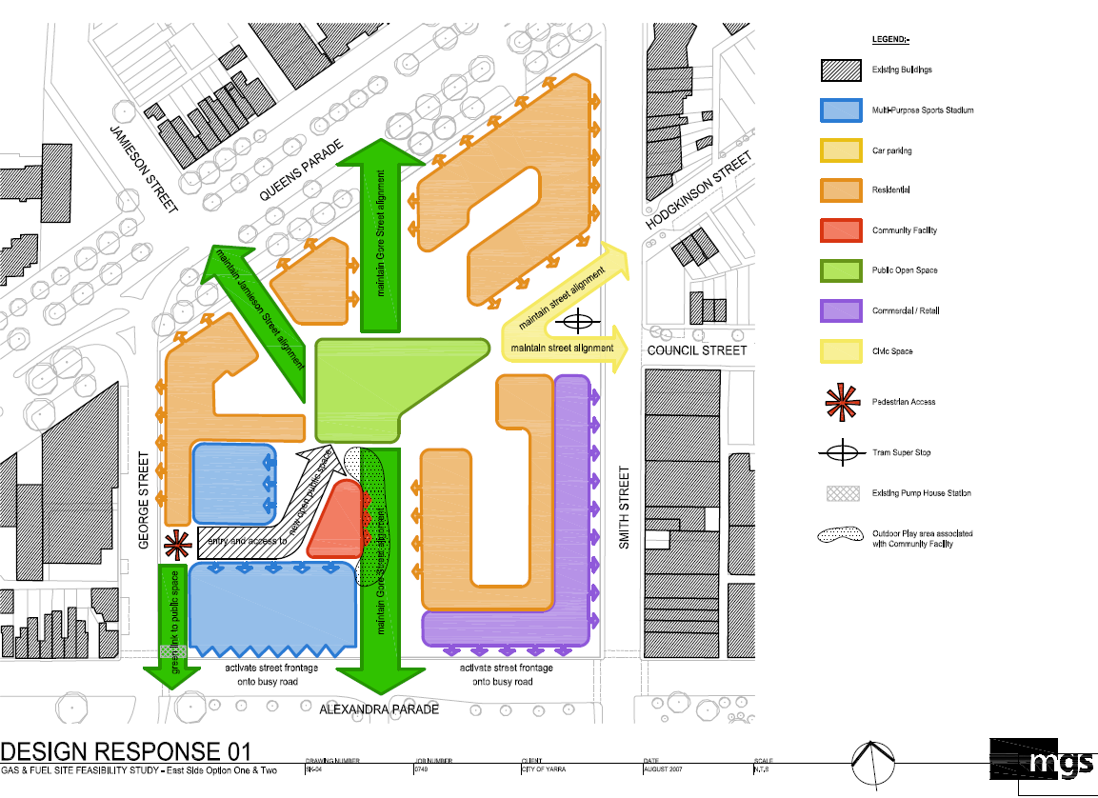

Refer, [Urban design expert witness evidence for City of Yarra to the East West Link, Eastern Section Assessment Committee by Rob McGauran](http://www.dpcd.vic.gov.au/__data/assets/pdf_file/0005/165929/McGauran-EWS-Appendices-1-and-2.pdf).[10]

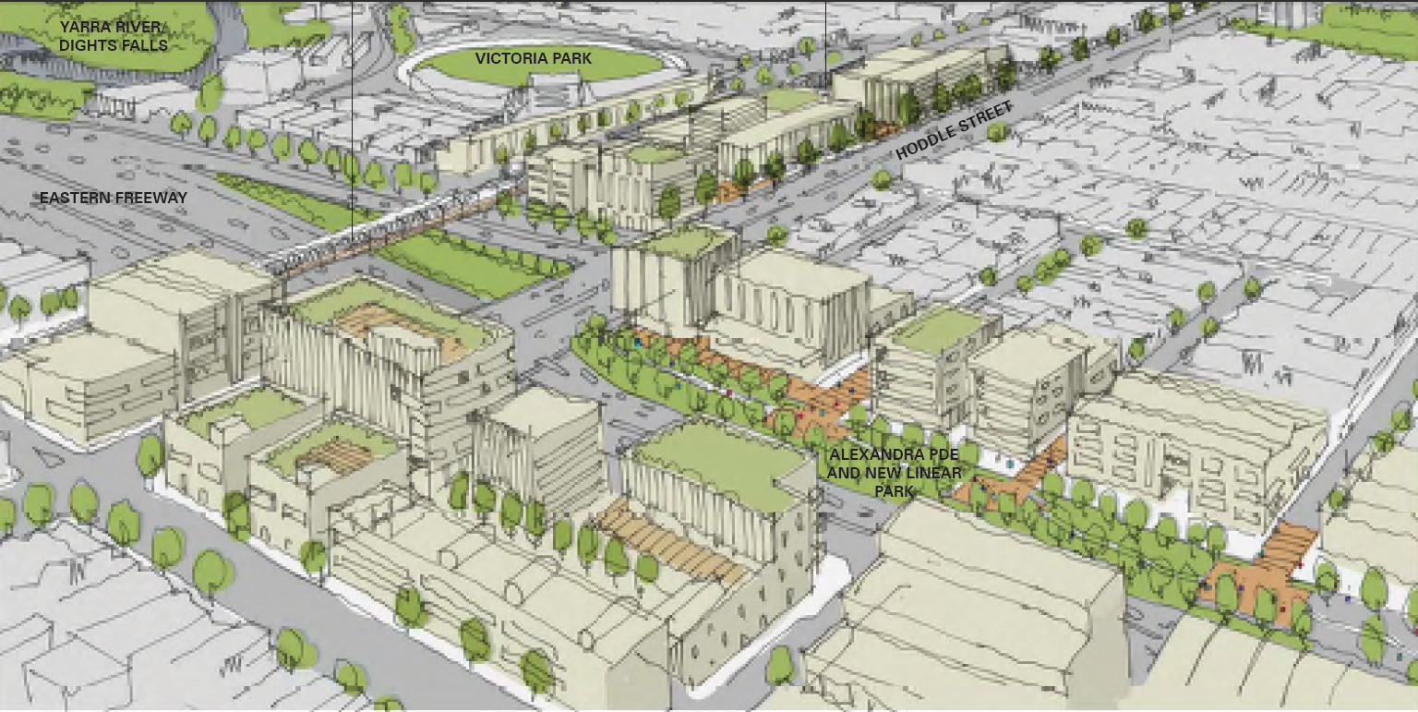

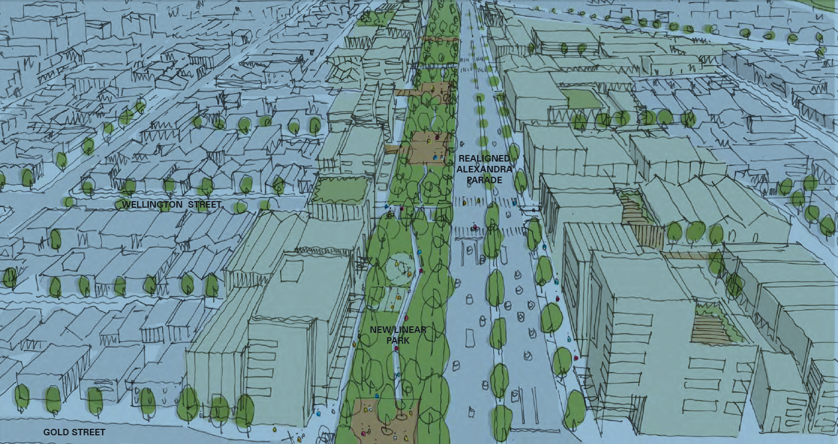

1. **Heritage**  
     
   The importance of heritage to the identity and character of the municipality C85, Clause 21.05 Built Form of MSS requires that:   
    *The cultural significance of heritage places must not be compromised by new development.[11]*

# References Review

1. **MSS Vision, Built Form**MSS Figure 1, Strategic Framework Plan  
   MSS Figure 2, Residential Opportunities Map  
   Residential Zones Implementation Advice **[12]**  
     
   Residential development analysis from DTPLI based on the 2011 Census data indicates that limited growth has occurred in the City’s residential areas. (Refer Table2).  
   This indicates that additional housing, particularly higher density housing largely occurs outside the municipality’s residential zone.

In considering the role of the Mixed Use, Commercial, Comprehensive and Priority Development Zones to the provision of housing, these past development trends suggest that higher density dwellings should continue to be provided and facilitated in these areas to meet the demand for medium and higher density housing.   
  
61% of new dwellings occurred outside of heritage precincts across all zones, with 11% being constructed within heritage precincts in the Residential 1 Zone   
(refer to Tables 2and 3) **[13]**.

1. **Amendment C85**, Clause 22.02-1 Policy Basis gives guidance for the protection and enhancement of the City’s identified places of cultural and natural heritage significance.
2. YARRA INDUSTRIAL AND BUSINESS LAND STRATEGY REVIEW, Final Report Prepared by Hansen Partnership and Charter Keck Cramer For City of Yarra, Sept 2004   
   http://www.yarracity.vic.gov.au/DownloadDocument.ashx?DocumentID=804

# Survey of under-developed land

Original Research by Graeme Loughlin, Sept 2014, for the 3068 Group

## Under-developed land Hoddle Street, Victoria Park

|  |  |  |  |  |  |
| --- | --- | --- | --- | --- | --- |
| **Location** | **Property** | **Occupation** | **Occupant** | **Zone** | **Heritage** |
| 217 Johnston Street cnr. Hoddle Street. | showroom | Former bank then tool box sales | Vacant | B1Z |  |
| 246 Hoddle Street, cnr. Johnston Street | 2 storey shop & dwelling | success fee lawyer former marble veneer showroom | Going to Court former Architectural Stone | B1Z |  |
| 234 Hoddle Street | warehouse | tyre sales and repairs | Collingwood Tyre and Brake | B3Z |  |
| 238 Hoddle Street | single storey store | Electrical supplies, sales | Middy’s Electrical | B3Z |  |
| 248 Hoddle Street | single storey store | Prosthetic sales | Wick’s Magnetic Pain Relief Devices | B3Z |  |
| 250 Hoddle Street | 2 storey showroom/ office | Lighting sales Travel service | Beacon Lighting,  STA Travel | B3Z |  |
|  | open | Convenience store & petrol station | Coles Express | B3Z |  |
| 294-296 Hoddle Street | Single story warehouse/ showroom | Bathroom supplies | Swan Hardware & Homebase | B3Z |  |
| 310 Hoddle Street | Single story warehouse/ showroom | Machine parts sales | Kaemo Ind.P/L | B3Z |  |
| 316 Hoddle Street | Single story warehouse/ showroom | Wicker furniture sales | Stylish Outdoors P/L | B3Z |  |
|  | Concrete batching plant | Concrete Products | Pioneer | B3Z |  |
| 324-328 Hoddle Street | Warehouses | Self-storage | Kennards Self Storage | B3Z? |  |

## Under-developed land Hoddle Street, Clifton Hill

|  |  |  |  |  |  |
| --- | --- | --- | --- | --- | --- |
| **Location** | **Property** | **Occupation** | **Occupant** | **Zone** | **Heritage** |
| 362 Hoddle Street | Warehouse | Panel beaters | Luxury Auto Body | B4Z |  |
| 372-374 Hoddle Street | Showroom | Shop-fittings sales | One Group Retail Experience | B4Z |  |
| 420 Hoddle Street | Timber yard | Timber & hardware sales | De Mar | B4Z |  |
| 422 Hoddle Street | Convenience store & petrol station |  | Caltex 7/Eleven |  |  |
| 501-511 Hoddle Street | 2 storey office | Community mental health service | Paul Mullin Centre | MUZ |  |
| rear of 249-261 Queens Parade | Vacant land | Drive- in customer pick-up | Bourne bathroom and kitchen Centre | MUZ |  |
| rear of 265 Queens Parade | Vacant land | On-site parking | former Aircraft Association of Australia |  |  |
| rear of 269 Queens Parade | Vacant land | On-site parking | Intelligent Insurance |  |  |
| Hoddle Street cnr. of 267-269 Queens Parade | Single storey office | Insurance broker | Intelligent Insurance | MUZ |  |

## Under-developed land Hoddle Street, North Fitzroy

|  |  |  |  |  |  |
| --- | --- | --- | --- | --- | --- |
| **Location** | **Property** | **Occupation** | **Occupant** | **Zone** | **Heritage** |
| 263-265 Queens Parade | Single storey office | Vacant | former Aircraft Association of Australia | MUZ |  |
| Hoddle Street & 249-261 Queens Parade | Single storey warehouse | Bathroom supplies | Bourne bathroom and kitchen Centre | MUZ |  |
| 243-247 Queens Parade | Single storey warehouse | Subject to PLN14/0311 5-11 stories 76 dwellings | Retail, former shoe factory | MUZ |  |
| 217-241 Queens Parade | three storey workshop part demolished | Subject to PLN12/888  VCAT P3189/2011,  Feb 2012 4 storeys,12 dwellings, 3 retail & 3 offices | Vacant, former Volksville car repairs | MUZ | HO |
| 213 Queens Parade,  6 Dummett Cres. | Single storey warehouse | Subject to PLN05/0996 5 storeys, 24 dwellings | Hurl’s Fitness Centre | MUZ | HO |
| 10 Drummett Cres. | vacant land |  |  | MUZ | HO |

# Appendix 1 - The 3068 Group’s Submission to Melbourne 2030 Audit, 2007

The 3068 Group fully supports the City of Yarra’s recommendation that “Melbourne 2030 be modified to recognise the distinction between activity centres in Inner Melbourne and the rest of Melbourne and that the related policies be amended to reflect such a distinction and that Melbourne 2030 be modified to support the implementation of the **Inner Regional Housing Statement** which identifies that the majority of new housing development can be accommodated on key strategic redevelopment sites many of which are close to activity centres.”

Activity Centres are a one-size-fits-all policy that makes no sense on the ground in the City of Yarra. The Government argues that Structure Plans give local council control over their activity centers. However, the Minister, the Department and Priority Development Panels regularly reject Yarra amendments on the grounds that they are inconsistent with Melbourne 2030.

Most recently Yarra’s MSS (C84) has been called into question for being inconsistent with the activity centres concept. On this issue, the interim panel report did not criticized the substance of the decision to direct residential development into former industrial sites, and accepts that Yarra will still meet population growth targets. However, the panel points out that the MSS would be inconsistent with the Activity Centre policy wedged into Clause 11 of the planning scheme by Melbourne 2030. Yarra’s entire planning scheme hinges on what discretion the panel allows in the design of its activity centres.

Melbourne 2030’s imperative for a more compact city applies universally and without discrimination. The plan was ostensibly focused on compacting lower density suburbs.

The inner region is already more dense and growing faster than Melbourne 2030 targets [Victoria in Future]. The entire inner urban area was already a kind of activity centre with a long history.

The historical development of the inner urban area predates the post-war suburban expansion and development patterns resulting from the motorcar, freeways and suburban sprawl. In Clifton Hill, Fitzroy and Collingwood, workers’ cottages surround old factories. Boot makers were very much in demand on account of all the walking people did. Later suburbs were made possible by the cable car, and later the train.

The motor car and road funding facilitated greater separation between industrial and residential areas. Because of the early development patterns, the level of walking, cycling and public transport use in the inner region is already much higher than the Melbourne average.

Car ownership in the inner region is generally lower per-capita though growing as a result of rising affluence [2006 Census] while dwelling sizes were generally smaller - but may also be growing and less densely occupied.

The Activity Centre pattern is more relevant to a two-garage outlying suburb but is inappropriate to the inner urban area and leading to perverse and adverse impacts.

Reasons for directing major residential developments away from Yarra’s historic shopping streets (and historic residential areas) includes the historic small freehold ownership pattern, the intense level of retail and entertainment activity, historic buildings not designed for residential/commercial mixed use and the potential impacts on the culture and tourism that sustain these streets. Although there are some opportunities for residential development, these must be managed so as not to destroy the important and historic function of these streets.

*The 3068 Group - Submission to Melbourne 2030 Audit September 2007.*

# Appendix 2 - Urban Design Frameworks for Key Redevelopment Sites and Precincts

## City of Yarra Report, 2004

*Excerpt from Chapter2, Background*

In its submission on Melbourne 2030 – Planning for Sustainable Growth, Council expressed its concern about the implications of the strategy, especially within the City of Yarra, in which five of the nominated Major Activity Centres are located: Bridge Road, Richmond; Swan Street, Richmond; Victoria St, Richmond; Brunswick St, Fitzroy; and Smith St, Fitzroy. It was Council’s view, that this would effectively enable almost all of Yarra to be subject to increased development and higher density housing, with the exception of a few small areas in North Fitzroy, North Carlton and Alphington.

The key concern in this regard would be the fact that many of these strips are covered by heritage overlays under the Yarra Planning Scheme, and any future development must meet the objectives for these areas. In addition, Yarra has a number of valued low-density residential areas that are not protected by Heritage controls. This, added to the limitations of the existing infrastructure serving Yarra’s activity centres, will place many constraints on major growth and development in the nominated areas.

Council submitted that within the City of Yarra there are suitable strategic redevelopment sites close to public transport and services, which could be the focus of future residential growth and mixed-use development in the City of Yarra over the next 30 years, with only limited housing growth encouraged in its major activity centres to minimise any adverse impact on the established character of these centres, as most of these centres have already reached their saturation point in terms of development.

# Appendix 3 – Heritage Studies in the Proposed RGZ

These maps show the heritage overlays in detail over some of the proposed overlays. The heritage overlay for Queens Parade is not shown.

Key:

* New zones **approximately** outlined in red.
* Black is individually significant
* Gray is contributory
* White is non-contributory

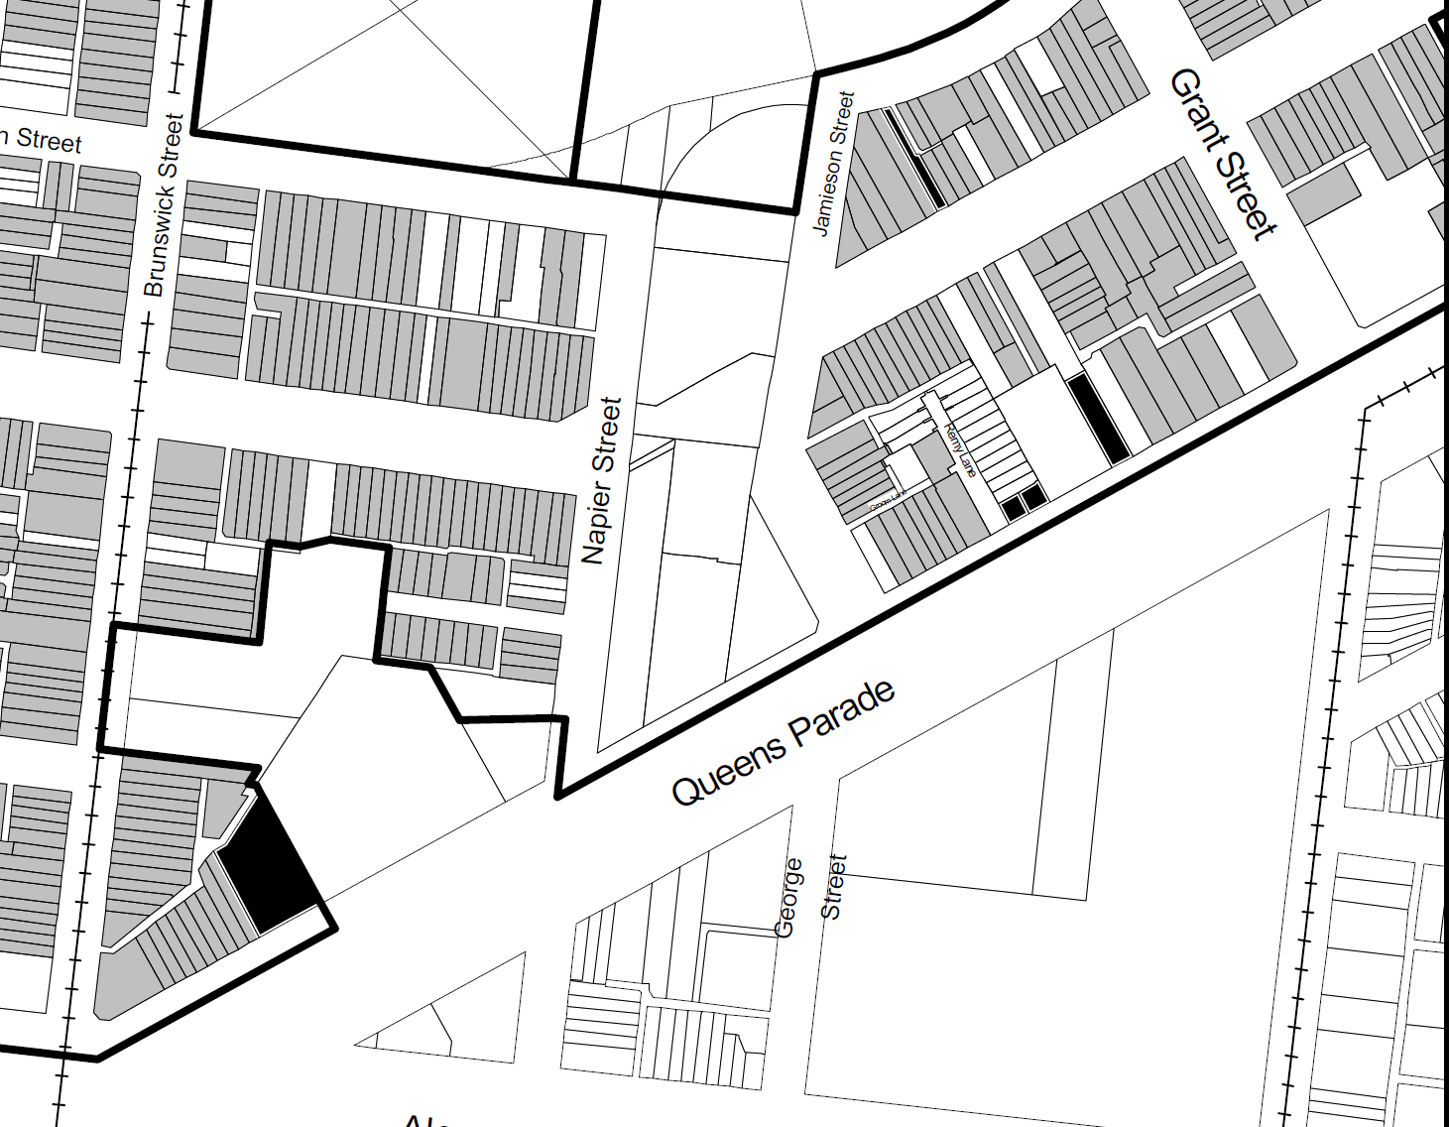

**HO327 Heritage Overlay**

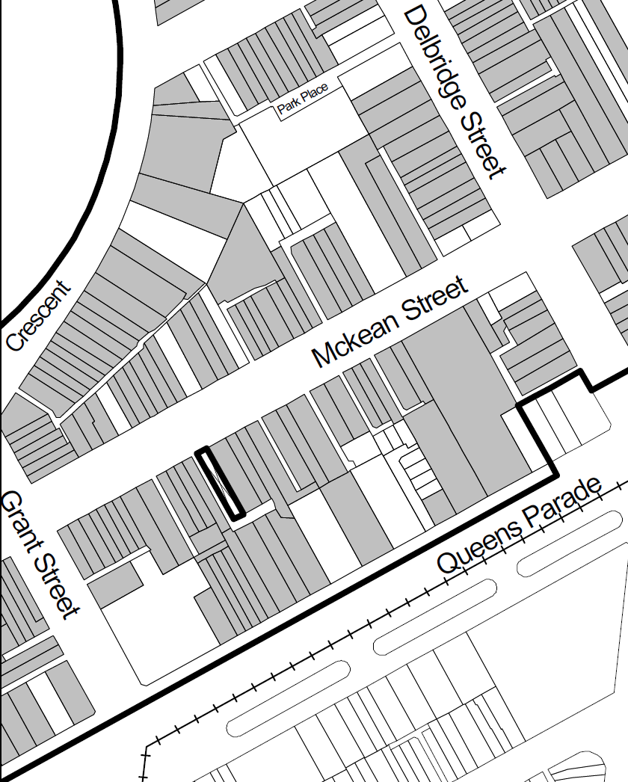

**HO327 Overlay**

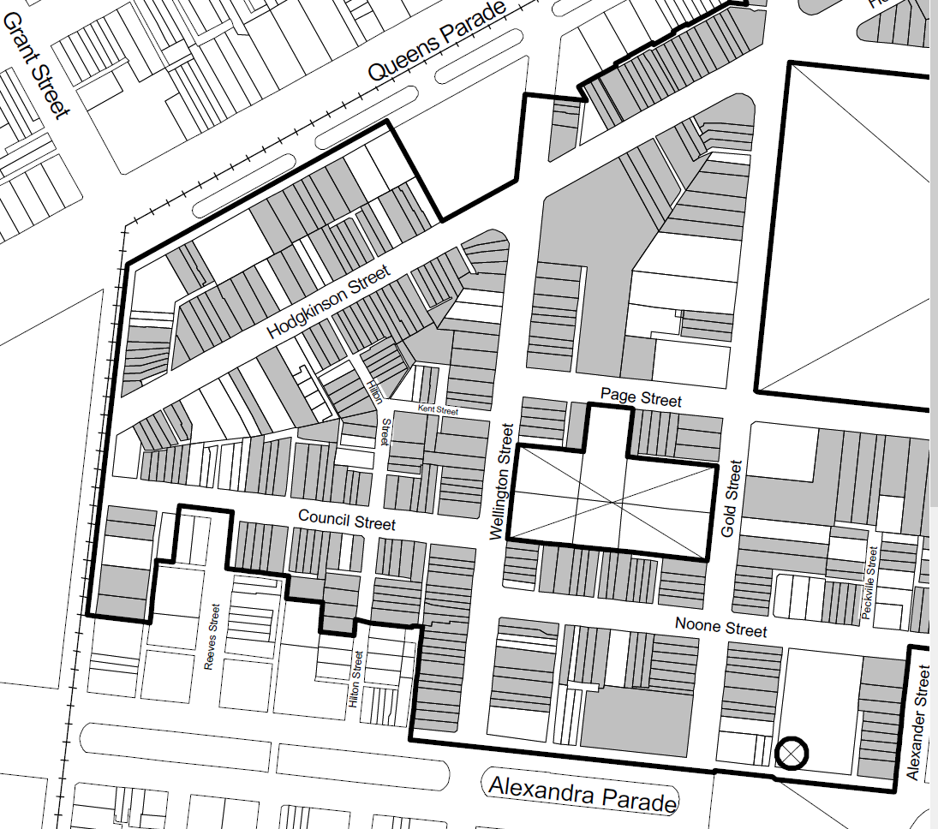

**HO317 Clifton Hill**

1. Michael Buxton, Professor Environment and Planning at RMIT University, Promises, Promises, Promises, Institute of Transportation Engineers Forum, Melbourne, 21 August, 2014
2. Amendment C82, Map No.2, Zones
3. Refer to Survey of under developed land, attached below
4. DTPLI, Planning Practice Note 78,Applying the Residential Zones , December, 2013, p.1
5. ibid.
6. YARRA PLANNING SCHEME AMENDMENT C84, FINAL PANEL REPORT: FEBRUARY 2008, 1.2.1 ‘Conflict between Melbourne 2030 and MSS on Activity centres’
7. ibid.p.2
8. Municipal Strategic Statement, clause 21.10,- Amendment C85, 2010.
9. Ibid.
10. http://www.dpcd.vic.gov.au/__data/assets/pdf_file/0005/165929/McGauran-EWS-Appendices-1-and-2.pdf
11. Municipal Strategic Statement , clause 21.05,- Amendment C85, 2010
12. Planisphere, planning and design, Residential Zones Implementation for the City of Yarra, October 2013, Draft Report, 2.1.1 Development Trends, p.10
13. Ibid.